**INSTALLATION PROCESS OF WORDPRESS IN WINDOWS(LOCALLY)**

**AND**

**BUILDING THE WEBSITE USING WORDPRESS**

1. **Downloading WordPress:**

* Open WordPress website by clicking on wordpress.org/download/
* Click on Download WordPress

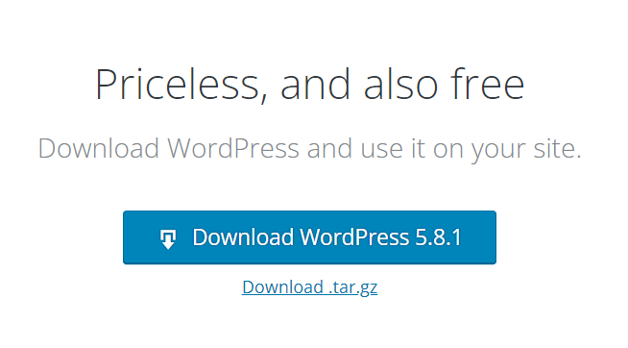

1. **Downloading XAMPP:**

* **Open apachefriends website by clicking on** [**www.apachefriends.org/download.html**](http://www.apachefriends.org/download.html)
* Download XAMPP according to system configuration.

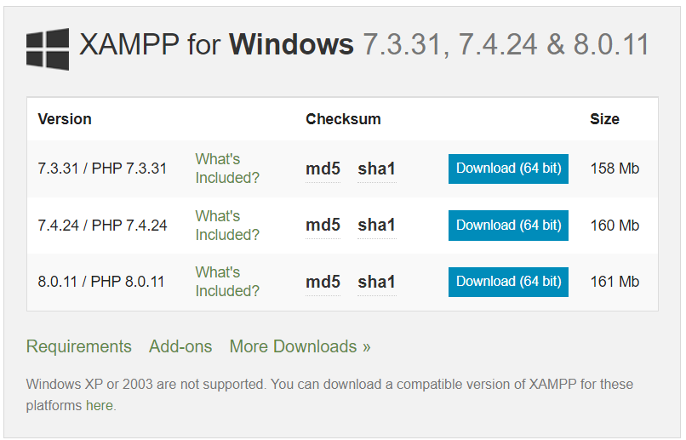

1. **Turning on Apache and MySQL:**

* After successful installation of XAMPP on system.
* Open XAMPP control panel, Start Apache and MySQL.

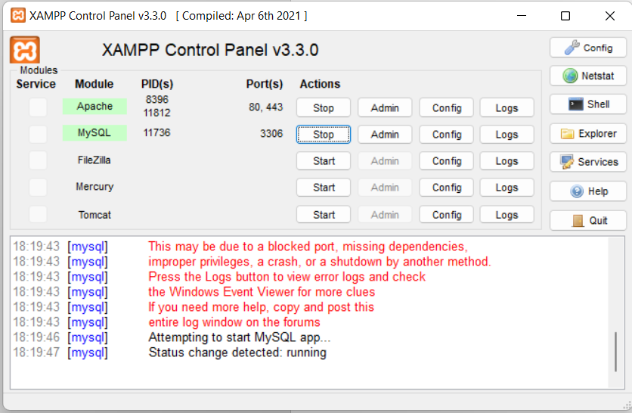

1. **Making WordPress available on localhost:**

* Identify on which drive XAMPP is installed on system.
* Now, extract and give name to folder(ex:ayvanminds_p1) move the WordPress file download in step 1 to ‘xampp->htdocs’ folder.

**Example (XAMPP on C drive):**

C:\xampp\htdocs\ ayvanminds_p1 \wordpress

1. **Creating a Database:**

* Make sure Apache and MySQL are turned on in XAMPP.
* Open any updated version of Browsers (ex: OperaGX, Chrome, etc...,)
* Type localhost/phpmyadmin/ in URL.
* Now, Click on Databases, give the name and click on create button.

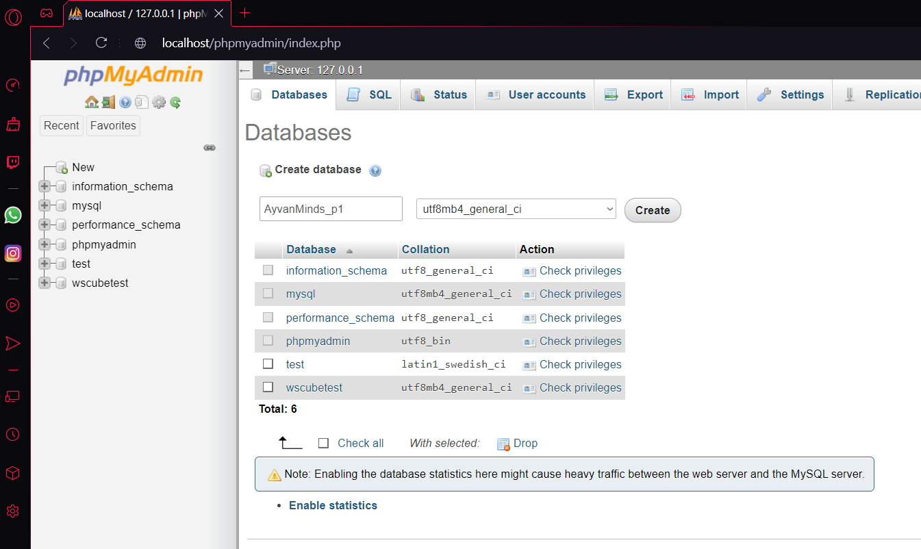

1. **Connecting Database to WordPress project:**

* Now in browser URL type following - <http://localhost/ayvanminds_p1/>

Here ayvanminds_p1 is the wordpress file name i.e, extracted in the step-4.

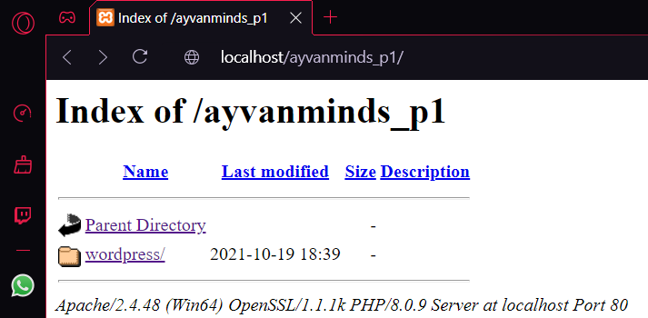 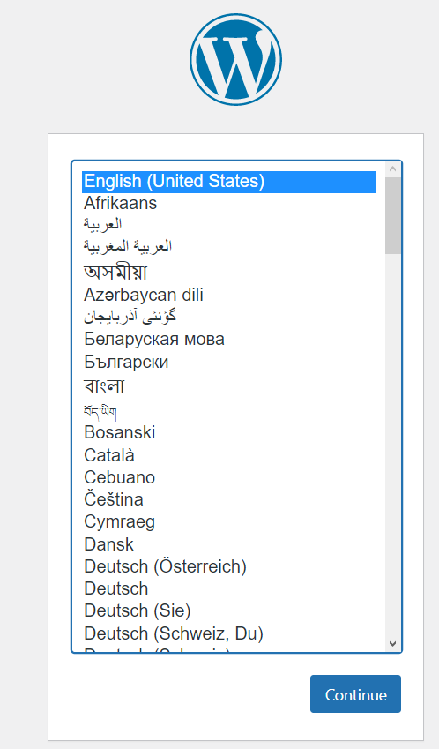

* Now select wordpress and choose preferred language and click continue.
* Now set Database Name as ayvanminds_p1, since that is the database we created in step-5 for this project.
* Set the site tile – Name of the website.
* Change Username to root, keep Password as empty and click on Submit.

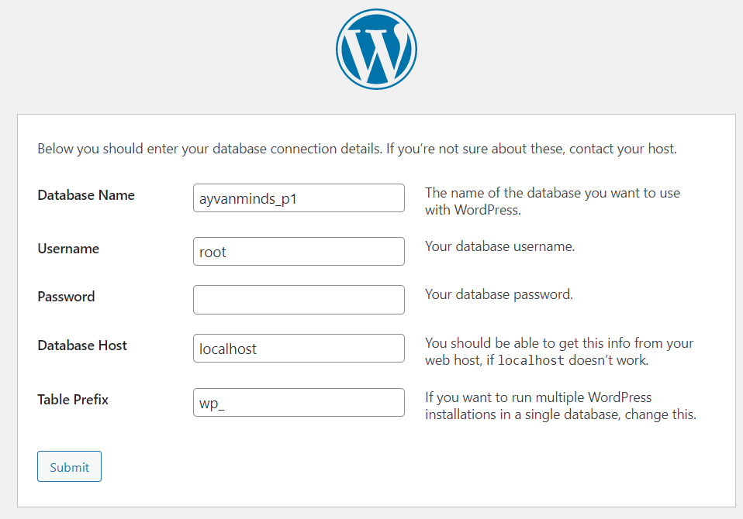

* Now it will ask to run the installation click on ‘Run the installation’.
* We will be redirected to Welcome page; there we need to setup admin information.
* Set the username to admin, password and admin email.
* Note don’t check search engine visibility if you want to allow search engines to crawl the website
* Now, click install WordPress.
* WordPress installation will be successful and you will be redirected to login page.

1. **Loging into admin for making changes to website:**

* Now type the following in the browser URL to get login page.

**localhost/ayvanminds_p1/wordpress/wp-login.php**

here ayvanminds_p1 is the wordpress file extracted in step - 4.

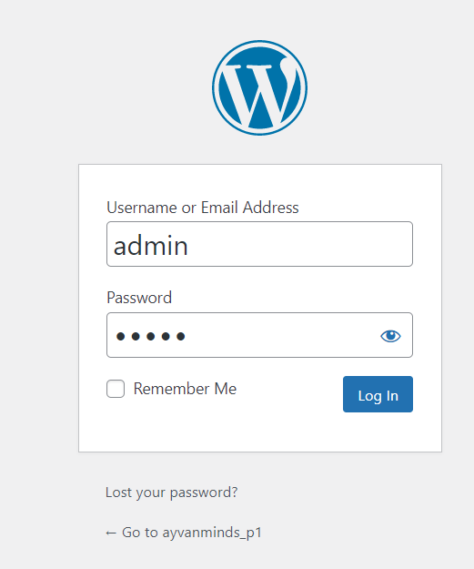

* Enter the username and password from step – 6.Hit login there we are in admin page of website.

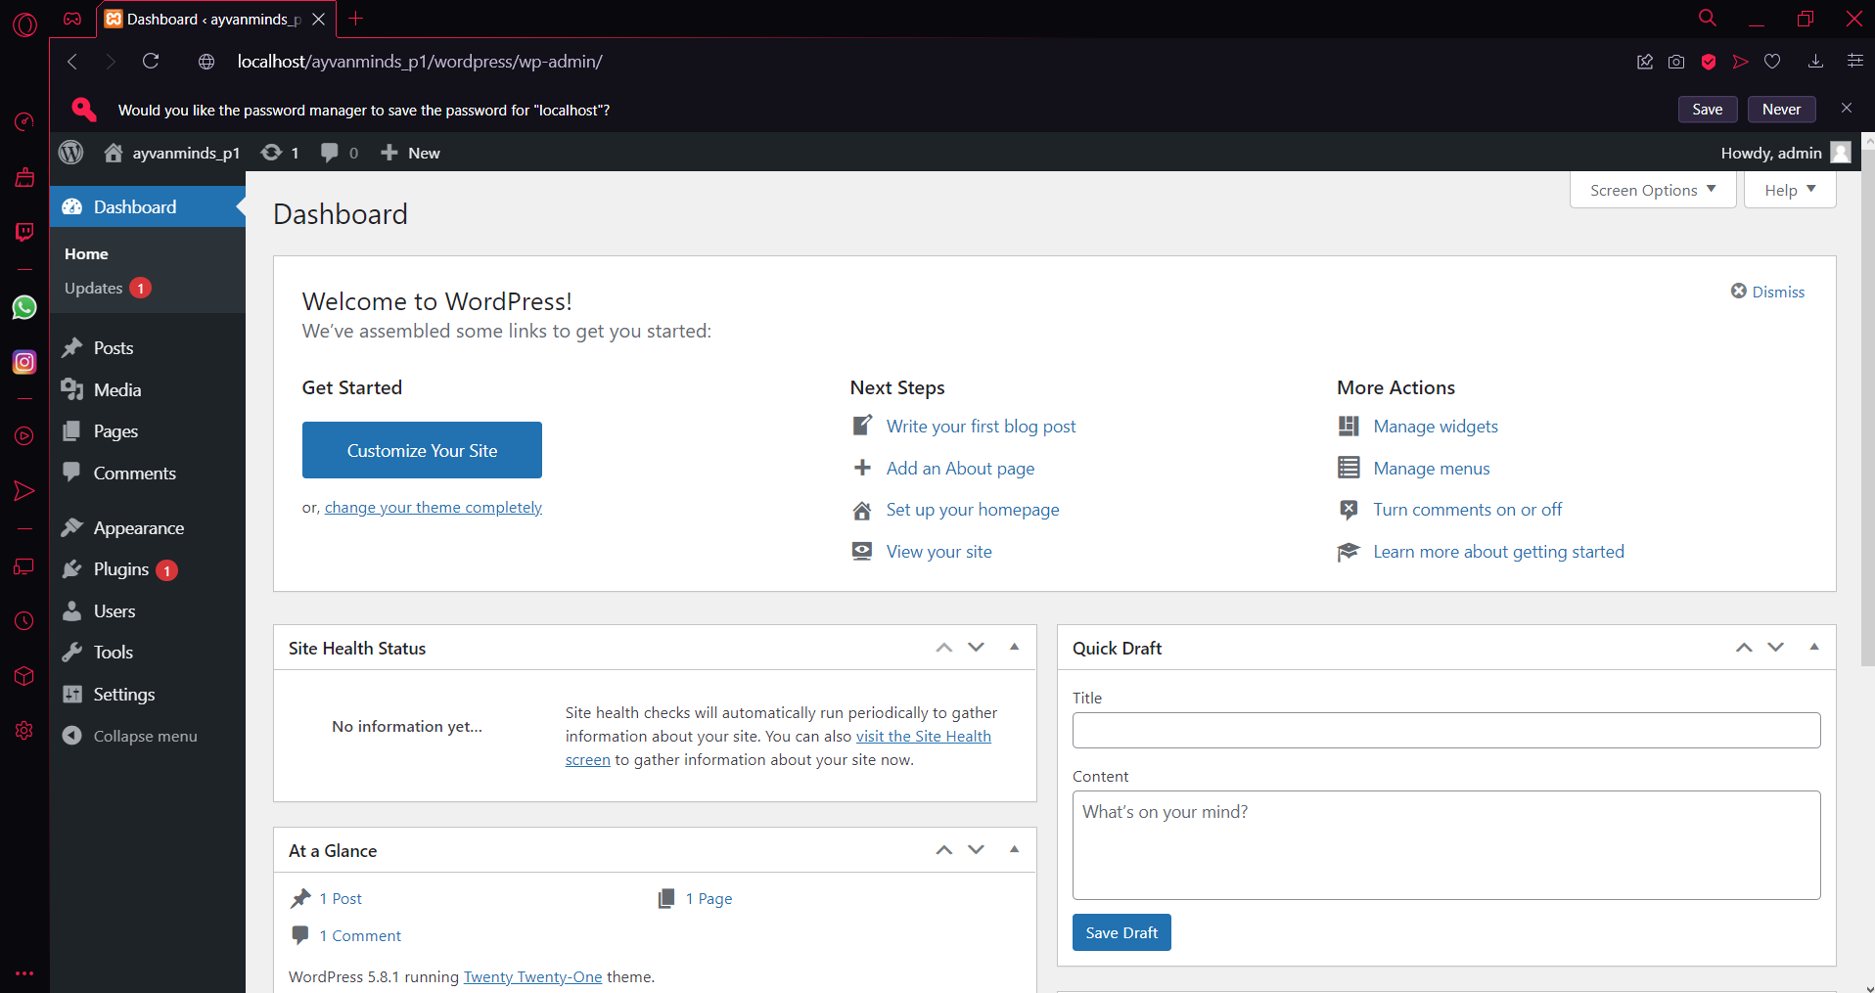

1. **Opening the Webpage:**

* Type localhost/ayvanminds_p1/ in browser URL and select wordpress and the website in now visible.

